Tutorial 1:

Hi, welcome to his tutorial for more advanced users of game maker. You will need full understanding of gml. This tutorial is intended for those who bought the uiZ asset over on the yoyo games marketplace. This is a very fast paste, simple and fast written tutorial. Don’t hesitate to look at the beginners tutorial is something is unclear or goes to fast in this tutorial. For other tutorials see:

-coming up

-coming up

-coming up.

Let’s get started! Just make a new object in a new room. Now you need to initialize uiz by calling uiz_init().

You need to know and remember the 4 main parts of uiz object creation:

-Creation

-setting parents

-setting variables/settings

-fixing.

We’ll get into parents later, but we’ll cover the rest now.

Creating objects, doesn’t require a special script and can be easily done using instance_create() but using uiz_c is recommended since it faster to use in coding. It takes one argument, which is the object you want to place. It also returns an instance id, which we’ll need later. We’ll make a square, which is called “obj_uiZ_square”. Type in “square=uiz_c(obj_uiZ_square)”.

We’ve created our object, but nothing will happen when the game is ran. We need to “fix” things first. Fixing is and should done a minimal amount of time to make things run faster. For this reason you’ll need to specify It in your own code. Just call “uiz_fixgeneralpos(square)” inside your create event. Fixing is also done when we resize our window for example. When the game is ran now, you should see a small white box in the left-top corner.

IMAGE 1:

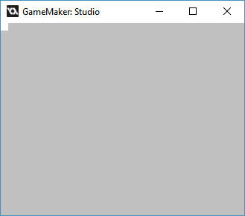

Now for positioning and sizing. There are a few variables we won’t cover in this tutorial, but are essential. Put the following code between the object creation and fixing part:

[CODE]

square.posinframex=px;

square.posinframey=px;

square.posvalwtype=px;

square.posvalhtype=px;

[/CODE]

You should understand the syntax “instance_id.variable_name=new_value”. If you don’t look it up in the game maker manual.

Now that stuff is out the way, we can set the position of the object with the variable “posvalx” and “posvaly”, and the size of our object with “posvalw” and “posvalh”.

Set the position to 100,200 and the size to 50x50. This should give you code like this:

Example 1:

[CODE]

//create event of a newly created object.

//initialize uiz

uiz_init()

//create our square object

square=uiz_c(obj_uiZ_square)

//setup some variables

square.posinframex=px;

square.posinframey=px;

square.posvalx=100;

square.posvaly=200;

square.posvalwtype=px;

square.posvalhtype=px;

square.posvalw=50;

square.posvalh=50;

//fix our square object.

uiz_fixgeneralpos(square)

[/CODE]

And it should look like this:

IMAGE 2:

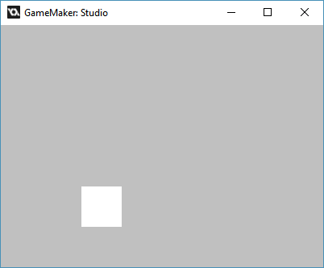

If this tutorial was too hard for you, then consider following the basic tutorial. Just know that you can always switch back and forth between the 2 versions since the same topics are covered every tutorial.